Carbonization Wind speed transmitter
(485Type)


Catalogue
Chapter 1 Product Introduction 3
1.1 Product Overview 3
1.2 Functional characteristics 3
1.3 Main parameters 3
Chapter 2 Hardware Connection 5
2.1 Pre-installation inspection of equipment 5
2.2 Interface description 5
2.2.1 Sensor wiring 5
2.3 Installation method 5
2.4 Notes 6
Chapter 3 Wilining instructions 6
3.1 The sensor is connected to the computer 6
3.2 The use of sensor monitoring software 7
Chapter 4 Communication protocol 8
4.1 Basic parameters of communication 8
4.2 Definition of data frame format 8
4.3 Register address 9
4.4 Examples and explanations of communication protocols 9
Chapter 5 Frequently Asked Questions and Solutions 9

Chapter 1 Product Introduction

1.1 Product Overview
The wind speed transmitter adopts the traditional three-wind cup wind speed sensor structure. The wind cup is made of carbon fiber material, which has high strength and good start-up. The built-in signal processing unit of the cup can output corresponding wind speed signals according to user needs, which can be widely used in meteorology, marine, environment, airport, port, laboratory, industry, agriculture and transportation and other fields.

1.2 Functional characteristics
- Measuring range: 0-30m/s or 0-60m/s, resolution 0.1m/s
- Anti-electromagnetic interference treatment
- Adopt the bottom out-of-line method to completely eliminate the aging problem of aviation plug rubber pads, and it is still waterproof for long-term use.
- Adopt high-performance imported bearings, small rotation resistance, accurate measurement
- Polycarbonate shell, high mechanical strength, high hardness, corrosion-resistant and rust-free,Can be used outdoors for a long time
- The structure and weight of the equipment are carefully designed and distributed, with small rotational inertia and sensitive response.
- Standard ModBus-RTU communication protocol, convenient access.

1.3 Main parameters
DC power supply (default) | - RS485: DC5~24V
Operating temperature of transmitter circuit | -40℃~+60℃, 0%RH~80%RH
Communication interface | 485 Communication (ModBus) Protocol  Baud rate: 2400, 4800, 9600 (default), 19200, 38400, 57600, 115200  Default ModBus communication address:3  Support function code: 03/0 6
Parameter setting | Use the provisioned configuration software to configure through the 485 interface
Resolution | 0.1m/s
Measuring range | 0~30m/s, other measurement ranges can be customized
Dynamic response time | <100ms
Precision | ±0.5 m/s
Start the wind speed | ≤0.5 m/s
For long-term use, please keep the ambient wind speed below 30m/s.

Shell Size:
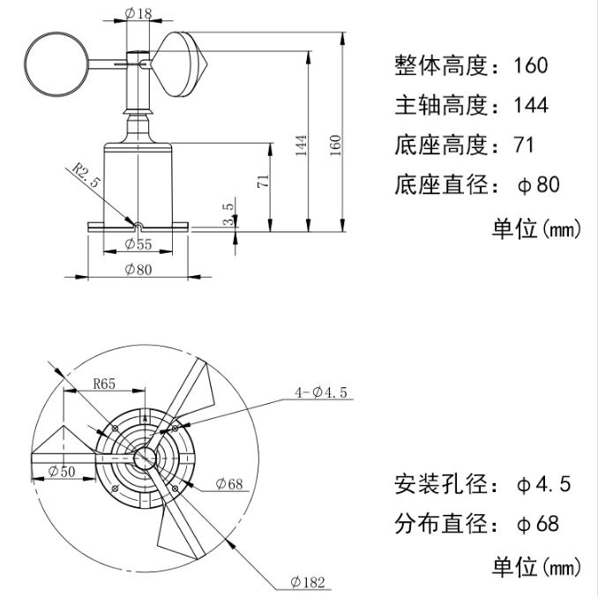

Chapter 2 Hardware Connection

2.1Pre-installation inspection of equipment
Equipment list:
■ 1 transmitter equipment
■ 4 mounting screws
■ Qualification certificate, warranty card

2.2 Interface description
The power interface is a wide-voltage power supply 5~12VInput. 485 Pay attention when wiring the signal line A\B The two lines cannot be reversed, and the addresses between multiple devices on the bus cannot conflict.

2.2.1 Sensor wiring
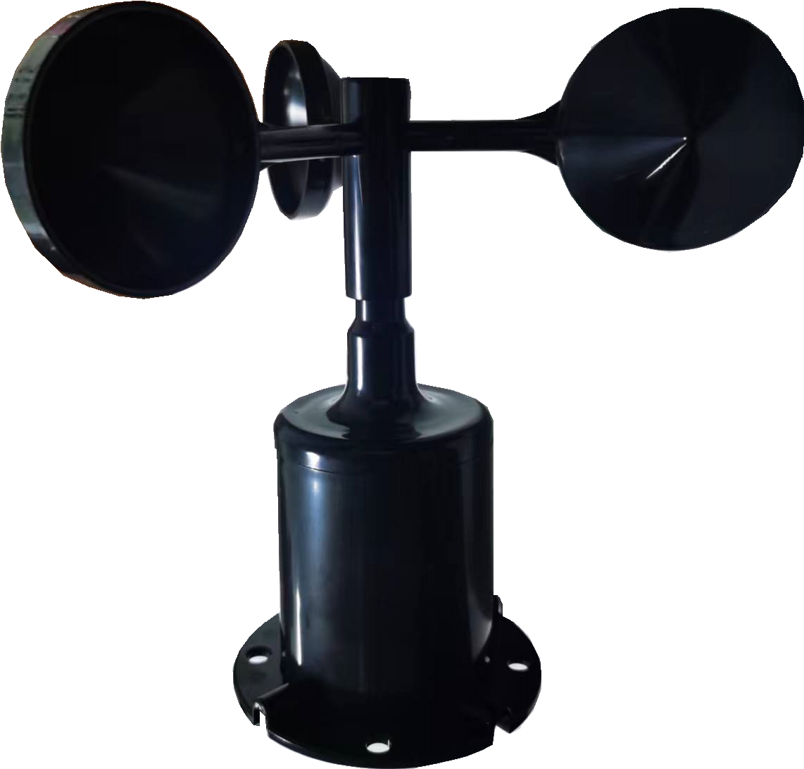
 | Line color | Explain
Power supply | Red | The power supply is positive
Power supply | Black | The power supply is negative
Send out | Yellow | 485-A
Send out | Green | 485-B

2.3 Installation method
With flange installation, the screw flange connection makes the lower pipe of the wind speed sensor firmly fixed to the flange plate, the chassis Ø65mm, four Ø6mm mounting holes are opened on the circumference of Ø47.1mm, and bolts are used to firmly fix it to the bracket to keep the whole instrument at the best level and ensure the accuracy of wind speed data. The flange connection

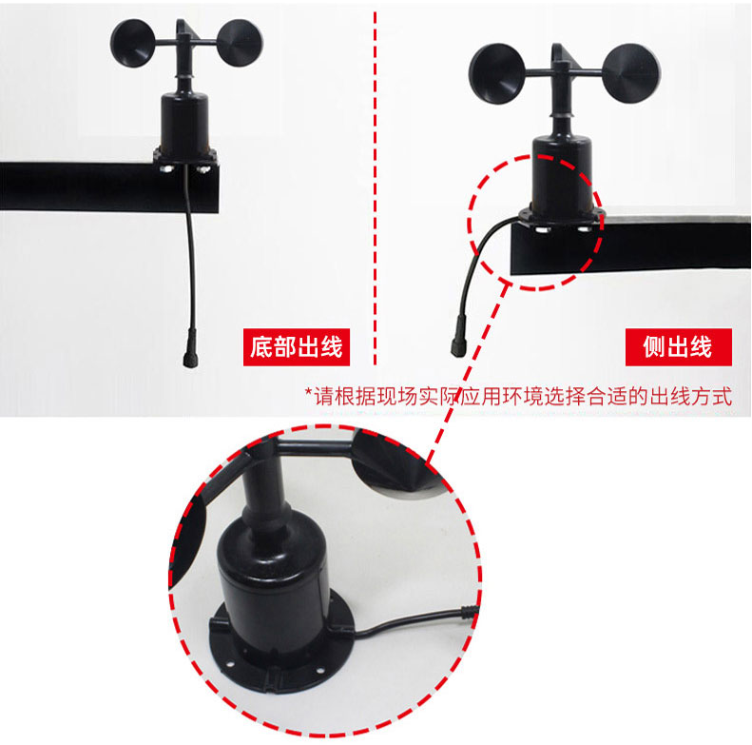

2.4 Notes
1. Users are not allowed to disassemble it by themselves, let alone touch the sensor core, so as not to damage the product.
2. Try to stay away from high-power interference equipment to avoid inaccurate measurement, such as frequency converters, motors, etc.When installing and disassembling the transmitter, the power supply must be disconnected first. Water entering the transmitter can lead to irreversible changes.
3. Prevent chemical reagents, oil, dust, etc. from directly infringing on the sensor, do not use it for a long time in condensation and extreme temperature environments, and strictly prevent cold and heat shocks.

Chapter 3 Communication protocol

4.1 Basic parameters of communication
Code | 8-bit binary
Data bit | 8 bit
Odd and even check bit | Not have
Stop position | 1 bit
Error check | CRC (Redundant Loop Code)
Baud rate | Factory default 9600bit/s

4.2 Definition of data frame format
The ModBus-RTU communication protocol is adopted, and the format is as follows:
Time of initial structure ≥4 bytes
Address code = 1 byte
Function code = 1 byte
DATA AREA = N BYTES
Error check = 16-bit CRC code
End structure ≥4 bytes of time
Address code: It is the address of the transmitter and is unique in the communication network (factory default 0x03).
Function code: Function instructions issued by the host, this transmitter only uses the function code 0x03 (number of read registers)
According to).
Data area: The data area is specific communication data, note that 16bits data high bytes are ahead!
CRC code: two-byte check code.
Host inquiry frame structure:
Address code | Function code | The starting address of the register | Register length | Low level of verification code | High-level verification code
1 byte | 1 byte | 2 bytes | 2 bytes | 1 byte | 1 byte

Address code | Function code | Number of effective bytes | Data District I | The second data area | The Nth data area | Verification code
1 byte | 1 byte | 1 byte | 2 bytes | 2 bytes | 2 bytes | 2 bytes
Query frame structure from the machine:

4.3 Register address
Register address | Content | Operate
0000H | Instantaneous wind speed  The uploaded data is 10 times the real value. | Read only
0001H | Wind Leve 0~12, unit level | Read only

4.4 Examples and explanations of communication protocols
Example: Read the wind speed of the device address 0x03
Address code | Function code | Starting address | Data length | Low level of verification code | High-level verification code
0x03 | 0x03 | 0x00 0x00 | 0x00 0x01 | 0x85 | 0xE8
Inquiry frame:

Address code | Function code | Return the number of valid bytes | Current wind speed value | Low level of verification code | High-level verification code
0x03 | 0x03 | 0x 02 | 0x00 0x56 | 0x41 | 0xBA
Reply Frame:(For example, read that the current wind speed is 8.6m/s)
Wind speed calculation:
Current wind speed:0056H (Sexadecimal number system )= 86 => Wind Fast Equal to 8.6m/s

Chapter 5 Frequently Asked Questions and Solutions
No output or output error
Possible reasons:
1.the computer has a COM port, and the selected port is incorrect.
2. Baud rate error.
3, 485 bus is disconnected, or A and B lines are reversed.
4. If the number of equipment is too large or the wiring is too long, power supply should be nearby, add 485 enhancers, and increase 120Ω terminal resistance.
5. The USB to 485 driver is not installed or damaged.
6. The equipment is damaged.

